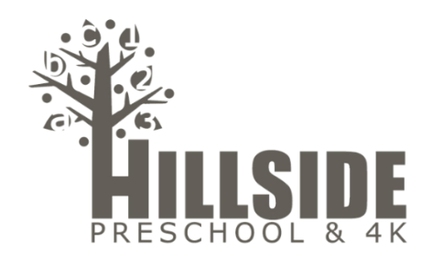
3k Supply List 2019-2020

- 1 Roll Scotch Tape Refill (M/W Class)
- 1 Container of Baby Wipes (T/TH Class)
- 1 Package of Napkins
- 1 Roll of Paper Towel
- 1 Container of Playdough, any color except blue! (We have an abundance of blue!)
- 1 Set of Crayola Watercolors
- 1 Composition Notebook, Labeled with Child’s Name
- 1 Standard Size Backpack (Should be able to fit a folder), Labeled with Child’s Name
- 1 Change of Clothing to be Kept in Backpack, Labeled with Child’s Name
- 1 _______________________________________________________
*Supplies will be community use, so only your child's notebook, backpack and extra change of clothing will need to be labeled. Please change out clothing as the seasons and your child’s size change. *

