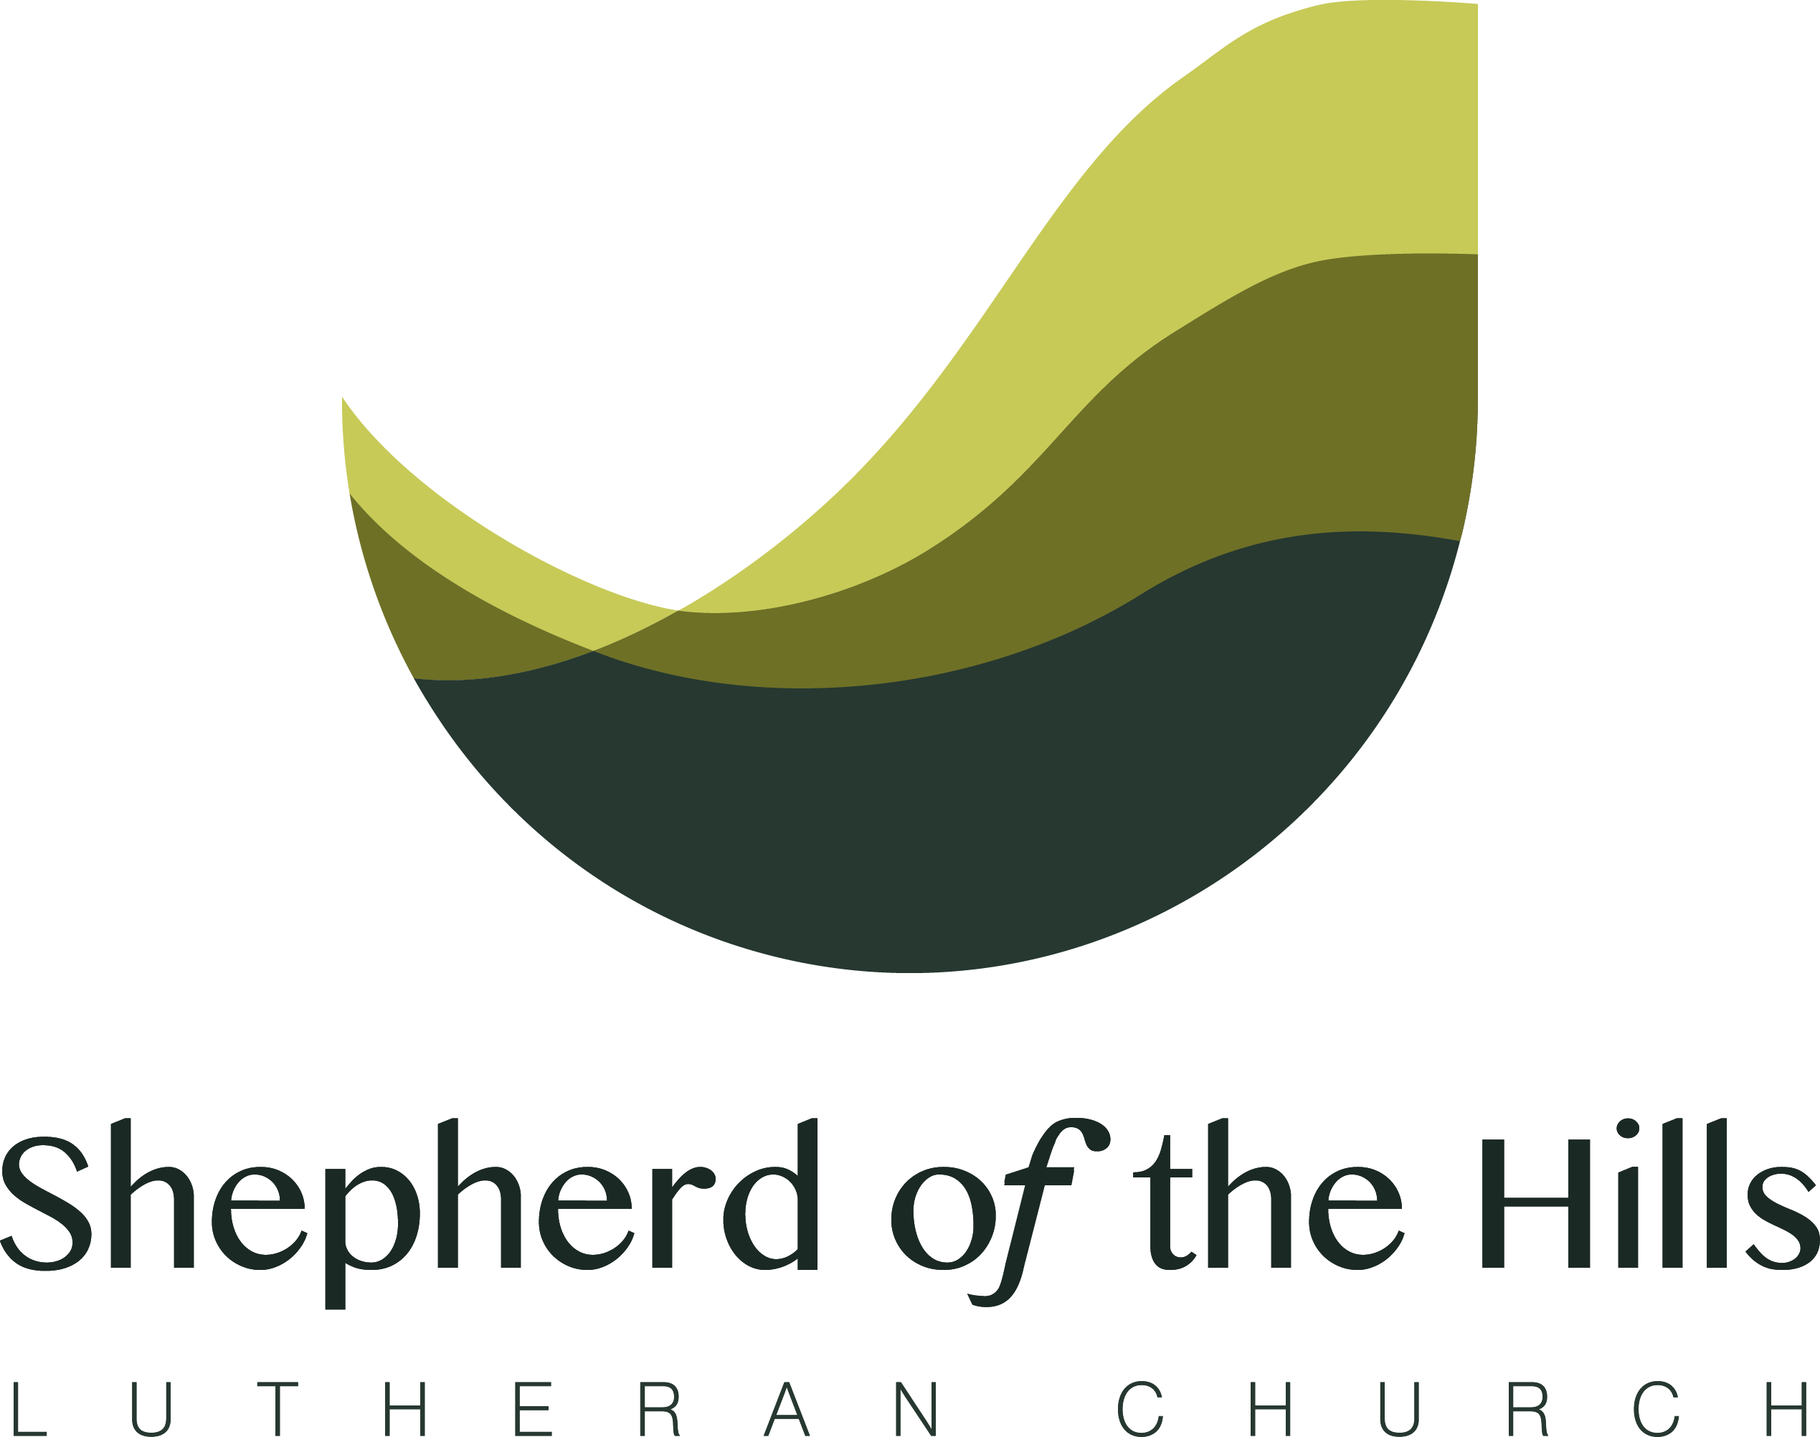Administrative Assistant (60% FTE)
Ministry Description

SUMMARY The Administrative Assistant provides communication, data management and secretarial support for the staff and congregation of SHLC. The position is for three days per week (Wednesday thru Friday) for a total of 24 hours weekly. The Administrative Assistant shares office space with the Financial Secretary, who works Monday thru Wednesday and shares in secretarial duties.

ACCOUNTABILITY The Administrative Assistant reports to the Senior Pastor of SHLC, and is accountable to the congregation through the Administrative Board.

QUALIFICATIONS
- The Administrative Assistant is a friendly person who greets people warmly in the office and on the phone.
- The Administrative Assistant is experienced in team settings and possesses the necessary skills and attributes to help the team succeed.
- The Administrative Assistant possesses advanced skills in Microsoft Office and related software, with the ability to produce quality publications for the congregation and community. Preference is given to those who have knowledge and experience working with Shepherd Staff Church Management software, though initial/ongoing training in Shepherd Staff will be provided.
- The Administrative Assistant is highly organized and consistently completes assigned tasks by their deadlines.
- The Administrative Assistant has at least 5 years experience working in an office setting, with preference given to those who have worked in a church office.
- The Administrative Assistant is either a committed Christian or highly respectful of Christian values and beliefs, with preference given to those who belong to, or are familiar with, the Lutheran Church.

PRIMARY DUTIES AND RESPONSIBILITIES:

- COMMUNICATIONS
  - Answer incoming calls, email, messages and regular mail, and direct them to the appropriate destination.
  - Greet and assist visitors.
  - Produce weekly worship bulletins, including special seasonal services.
  - Produce and distribute monthly newsletters, as well as congregational correspondence.
  - Assist with content for website and social media distribution.
  - Prepare and disseminate correspondence with individuals and/or congregations as needed or assigned.

- DATA MANAGEMENT
  - Keep digital and paper files organized and up to date.
  - Maintain membership list, birthday and anniversary lists, volunteer lists, and new member tracking and communication.
  - Maintain records of all Official Acts (baptisms, confirmations, weddings, funerals) and the official Constitution and Bylaws of SHLC, including any amendments or revisions.
  - Produce and maintain annually the member directory, including updated contact information.
  - Prepare monthly Pastoral Report, as well as Annual Report for the congregation and Statistical Report for the Lutheran Church Missouri Synod.

- SECRETARIAL SUPPORT
  - Maintain and distribute weekly and monthly church calendar of all events, including scheduling for building use and Official Acts.
  - Gather, store and distribute the minutes from all Board and Ministry Team meetings, as well as congregation meetings.
  - Assist called and support staff in completing ministry projects as needed.
  - Coordinate with the Financial Secretary on purchasing supplies and maintaining office equipment.
  - Other duties as assigned.

- TEAM
  - Uphold the constitution, bylaws, mission, vision and values of SHLC.
  - Participate in daily/weekly staff devotions.
  - Attend regular staff meetings and retreats, as requested.
  - Be prepared to work additional paid hours during busy seasons.
  - Sign and be held accountable to the Team Covenant and the Professional Expectations agreement.
COMPENSATION
- Starting wage is $15-$17/hour based on experience; retirement and disability plan provided.
- Paid holidays, days off and vacation as outlined in the Employee Handbook.
- Biannual reviews with the Senior Pastor to determine future compensation.

COVENANTS
- The congregation and surrounding staff will love and care for the Administrative Assistant, and the Administrative Assistant will love and care for the congregation and the surrounding staff.

- The congregation will provide fair compensation for the Administrative Assistant, and the Administrative Assistant will work hard to advance the mission and ministry of the congregation.

- The congregation will determine goals and objectives for the ministry of Christ in this place and provide resources for achieving them, and the Administrative Assistant – along with the rest of the staff – agrees to be held accountable to those goals and objectives.

- The congregation will strive to live lives worthy of the calling we have received in Christ, especially in relationship to the Administrative Assistant, and the Administrative Assistant will do the same.

- The congregation recognizes that special circumstances may arise and paradigms may shift, so we will make necessary adjustments in those times of change; the Administrative Assistant will be willing and ready to adapt when the Lord changes our direction.

Shepherd of the Hills Lutheran Church
N1615 Meadowview Drive Greenville, WI 54942
920-757-5722
Email: office@shepherdhills.org
Website: shepherdhills.org

