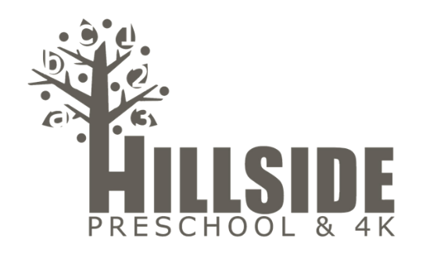

Hillside 3 Year Old Preschool
Supply List 2021-2022

1  3  1  1  2  1  1  1  4  1  1  1  1 | Labeled with Child’s Name  plastic school box  .77 oz Elmer’s glue sticks  pair of child size scissors  box of 24 count crayons  packs of classic color washable markers  composition notebook  change of clothing (including socks and underwear) to be kept in backpack  standard size backpack (many of our art projects do not fit in a small backpack)  containers of playdough (your child’s choice of color)  Do Not Label  package of napkins (T/Th girls)  roll paper towel (all boys)  box of 5 oz paper cups (M/W girls)  Supplies can be brought in during  Open House or on the First Day of School.

